Ideation Phase
Empathize & Discover

Date | 25 July 2025
Team ID | PNT2025TMID08395
Project Name | Visualizing Housing Market Trends: An Analysis of Sale Prices and Features using Tableau
Maximum Marks | 4 Marks

Empathy Map Canvas:
An empathy map is a simple, easy-to-digest visual that captures knowledge about a user’s behaviours and attitudes.

It is a useful tool to helps teams better understand their users.
Creating an effective solution requires understanding the true problem and the person who is experiencing it. The exercise of creating the map helps participants consider things from the user’s perspective along with his or her goals and challenges.
Example:
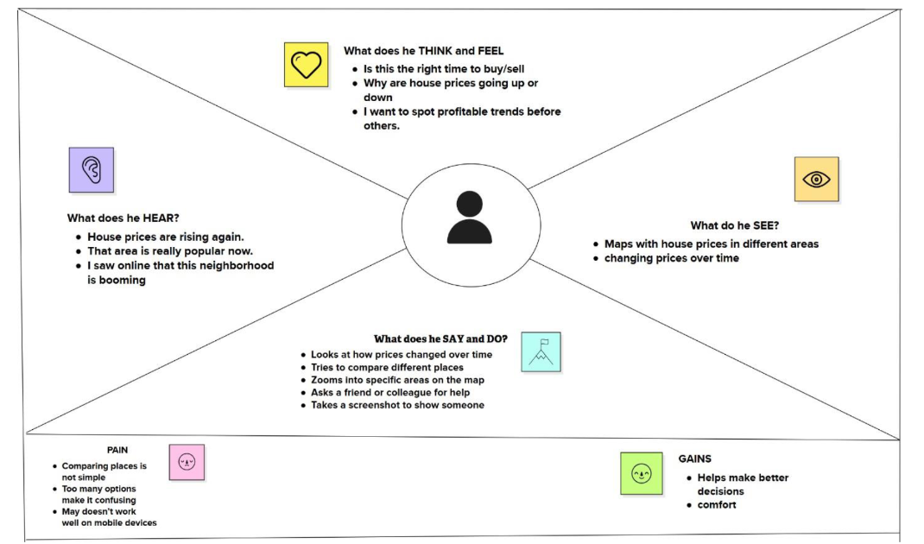

Reference: https://www.mural.co/templates/empathy-map-canvas

Example: Food Ordering & Delivery Application
